Informal or formal tone?
If the people you are writing to is a friend of yours, use informal tone, otherwise use formal tone.

Informal Structure
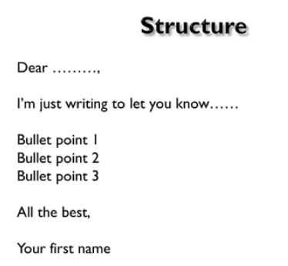

Informal Sample:
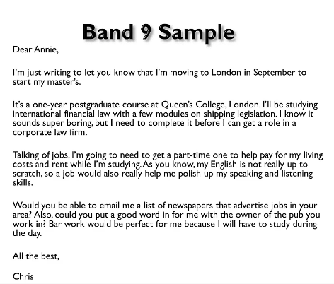
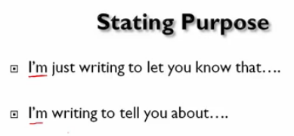
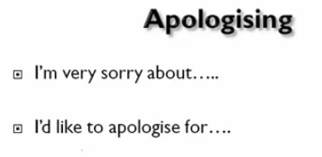
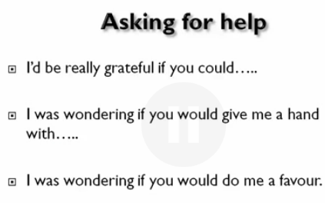
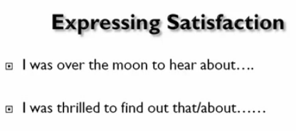
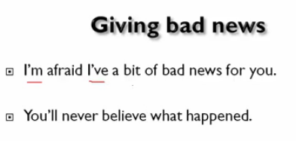
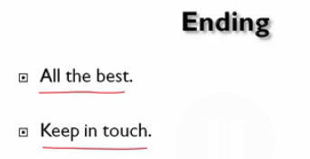

Formal letters:

Formal structure:
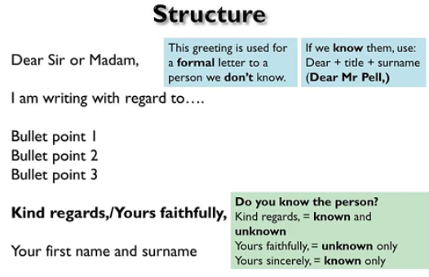
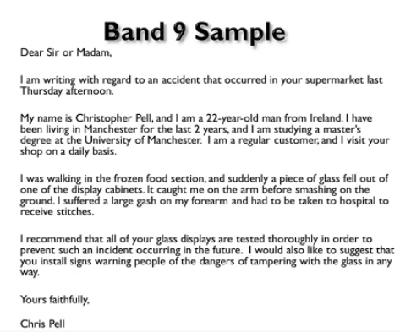
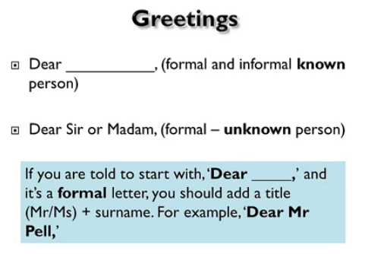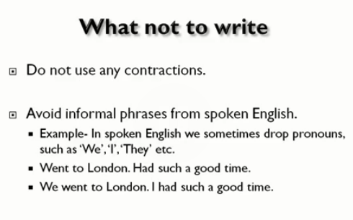
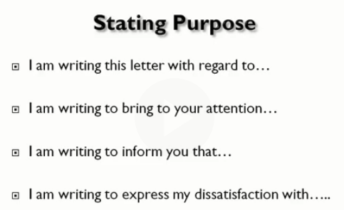
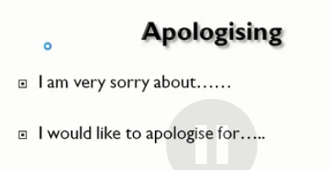
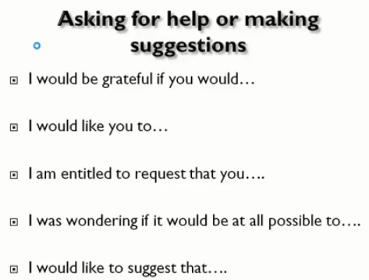
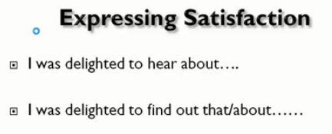
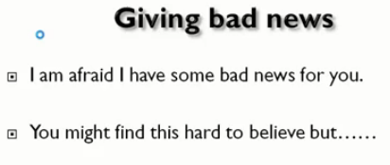
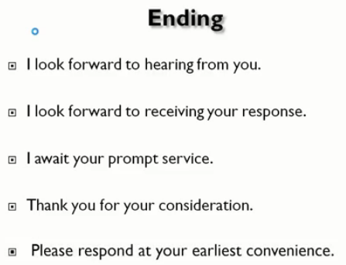

如果是写给一个你不认识的人，第一句话应该做一个简短的自我介绍。

最后一段 是 call to response or action，要不提出你希望得到一个回复，要不提出你希望对方采取什么措施

没什么可说的情况，可以就是 I appreciate your time reading the letter.
I appreciate your taking the time to read this letter.
因为 taking the time 是一个名词 前面要用your 才是语法正确的
或 I appreciate you for taking the time to read this letter.
I hope to see your response on Main Street soon.

在informal 的信件中，你的最后一段可以是以下的
Close with a call to action, offer, or clear ending
(I look forward to seeing you again; let me know if you need anything; call me when you get into town; I can’t wait to see you; etc.)

Informal letter 的开头 可以先来一些 chitchat 不需要直入主题
Introduction
Be friendly.
Use an Icebreaker.
State the purpose of the letter.

You have recently landed in a foreign country on a work visa and need information about the place in and around the city.

Write a letter to the relocation assistance provider seeking help
and in your letter,
Write why you are writing the letter obstacles when using other methods
What kind of information you want need
How and by when you can get the requested information

Dear Sir or Madam,

I am writing this letter to ask for some information related to living in Tucson since I just relocated to here one week ago.

The reason why I choose to contact you is that your email address was recommended on by the Tucson city government when I was searching for essential information on their website. I suppose you must have the most detailed and reliable information than any other sources.

I want to know if there is any community here for foreigners, especially Chinese communities, since that would be much easier for us to communicate. In addition, information about local language schools would be really helpful as my English still needs some improvements to communicate effectively at the workplace.

When can I get the information? To be honest, I am in urgent need of them since my money is running out pretty soon if I continue to live like this on my own. It will be of great help if you can provide them for me as soon as possible. Also, remember to include the methods needed for me to get them. Personally, I prefer downloading them to my computer.

I look forward to hearing from you very soon.

Yours faithfully,

Bo Zhu

Relocate here 中间不需要介词 to
Recommended by the government 而不是 on

A local college is having an international day.
You want to speak about your country to students from different cultures.
Write a letter to the college head.

In your letter:
Tell him/her about the topics that you are going to talk about
Explain why they would be of interest to the students
Ask about any arrangements that you need to make to give the talk

Culture customs food, tourist attractions, introduction to capital city
Since our country is too far away,it is hard for them to know what it really looks like, difference
Who I have to contact with in order to get my speech arranged

Dear Mr. Smith,

I am writing this letter to express my intention to introduce my home country to students from all over the world on our college’s international day.

I would like to introduce the topics that I would cover. Since many of our students are foodies, I would first introduce the traditional food of our country as there are a variety of them. Then I would like to describe several most famous tourist attractions in China, photos of these places would be included in the PowerPoint.

They must be interested in what I am going to present because the differences in cultures between China and western societies are just mind-boggling. China is still a mysterious country that not many foreigners have stepped into. I will show them what real China is like and share some of my personal experiences at the same time.

By the way, what else do I need to do to ensure that my speech will be arranged properly? I have prepared for it for a long time, and I want the organizer to have enough time for the perfect arrangement. It is in everyone’s best interest to get informed as early as possible.

I am looking forward to hearing from you very soon!

Yours sincerely,

Bo Zhu

PowerPoint 是一个单词 而不是两个单词 而且首字母大写
Mind-boggling 中间有连接符
Contact 是及物动词，后面不需要跟介词 with
Some of my personal experiences 经验应该是复数 单复数才符合
There is a variety of differences 或者 there are 都可以和variety 符合，具体看你想强调什么
Differences in cultures 而不是 of cultures
应该是 Is there anyone else 而不是 直接 anyone else 显得更加正式
It would be in everyone’s interest 而不是 of everyone’s interest

You have just finished your master’s degree and need to leave your current part-time job to search for full-time employment.
Write a letter to your current employer.

In your letter
explain why you will not pursue a full-time job in his/her company
say why you’ve enjoyed working for him/her
tell him/her how much longer you will continue to work for him/her.

Dear Mr Smith,

I am writing this letter to inform you that I am going to leave the company soon to find a full-time position as I have just finished my master’s degree in software engineering.

I am not considering transferring to a full-time position in your company since the major I have just finished has little to do with hydroelectricity which is the industry of your company, and your company is not going to utilize any software system in the near future.

It has been a pleasure working for your company. Everyone here has been very hospitable and friendly so far. They were fully aware that I had academic tasks to complete aside, and all of them were willing to give me a helping hand whenever it is needed. For this reason, I was able to keep this job and finished my study smoothly.

I would still be working here until the end of the next month. I understand that it would take some time for you to hire someone else to fill up my current position. Also, I would be able to use this time to inform other employees about what content my job was consisted of and transfer all the necessary documents to them.

I hope the best for you and your business in the future. Let me know if there is anything I missed.

Yours sincerely,

Bo Zhu

Master’s degree 而不是 master degree
Hydroelectricity 而不是 hydro-electricity
Consist 是动词 所以就是 what content my job consisted of

You have recently applied for a course at a college and have been accepted. However, you cannot join the course due to some reasons.
Write a letter to the principal of the college.
In your letter:
which course you have been applied for
why you cannot join the course
ask about the possibility of the course in the future

Dear Mr. Smith,

I am writing this letter to inform you about the issue that prevented me from being successfully enrolled in the course I applied for.

The course I applied for is Software Engineering 430, it is a course about algorithms. It teaches basic algorithm knowledge which is necessary for any developer aiming to find related jobs. It is also important in the sense that it is the foundation course for applying for more advanced algorithm courses.

The reason that I cannot join the course is that they have decided to transfer my position to another senior student who applied after me since he needs this course to graduate more urgently than I do. If there is no one giving up his position before the end of this week, I will have to wait for the next time when the course is open.

I want to know when this course would likely be open again in the future. I have waited for it for the last three semesters, however, it was not available due to a range of different incidents. I hope to be able to take it as soon as possible since writing it on my resume is extremely conducive to my career.

I look forward to your response very soon. Please let me know if there is any other way that I could be enrolled in the course.

Yours sincerely,

Bo Zhu

前置课 pre-course
About algorithms 关于算法 应该加复数
It teaches algorithms， teach 是不及物动词，所以后面不跟about
Conducive to my career 而不是 for

A large company in your area has decided to spend a certain amount of money, either to sponsor a local children’s sports team for two years, or to pay for two open-air concerts. It has asked for feedback from the general public.
write a letter to the company. In your letter
Describe the benefits of sponsoring the sport team
Summaries the benefits of paying for the concerts
Say how you think the company should spend the money

Dear Sir or Madam,

I am a citizen living in the same area where your company is located, I am writing this letter to recommend you sponsor the local children’s sports team.

The benefits of sponsoring the sports team are manifold. It can encourage more children to do sports activities instead of leading a sedentary lifestyle sitting before their computers or TVs at home. In addition, your company’s name would be presented at every competition the sports team participates in, which could raise your brand awareness significantly.

On the other hand, the benefits of paying for the concerts are not that obvious. I know that citizens would have some instant pleasure and gratifications but they would forget who paid for it very fast. On top of that, the price of paying for open-air concerts is prohibitively high so it just cannot be justified by the return your company would get from it.

I definitely believe that investing in the sports team would be the best choice. It is not only economical for the company but also cost-effective in terms of raising awareness of the company’s brand. After all, it is also an effort to improve public health.

I appreciate your taking the time to read this letter, and I hope you take my advice.

Yours faithfully,

Bo Zhu

Recommend sb. do something 不是to do
或者可以使用 recommend sb. Doing something
Hope sb. Do something 不是 to do
这两块实际上都是省略了that的情况
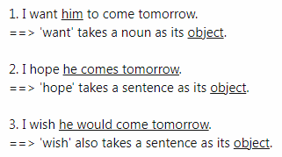
你如果不确定 这个单词能不能 拿一个 名词做宾语，能用句子做宾语那你就用句子

Raise brand awareness 是固定搭配 不需要 the brand awareness
Raise awareness 是固定搭配 不需要 raise the awareness
The price for XXX is 应该用is 而不是 are
公共健康 Public health 前面不需要加 the

如果你不确定是否要加 the 可以在那个位置放一个主格

You took an elderly member of your family, who was not able to walk properly, to a museum and he/she faced a few problems.
Write a letter to the manager of the museum.
In your letter,
say why you visited the museum
describe the problems you faced
suggest what can be done to avoid those problems

Dear Sir or Madam,

I am a local citizen who has just visited your museum with my grandpa whose legs are disabled. I am writing this letter to inform you about several issues faced by my grandpa and make some suggestions.

The reason why I took my grandpa to the museum is that he has not visited the museum for several decades and he wants to see how things have changed so badly. He also has not stepped out of his house for many years due to his disabilities.

We faced a variety of problems when visiting the museum. First of all, it was very hard for us to go upstairs or downstairs since there is no other way than climbing the stairs, and I had to carry the whole wheelchair with him sitting on it. In addition, the entrances to many areas are too small to pass through on a wheelchair.

I suppose many measures could be taken to mitigate the issues. Installing an elevator in specific areas would be especially helpful for people with disabilities. Reconstructing or enlarging those entrances which are too narrow should also be considered, and it is important to ensure that all obstacles are removed at these entrances.

I hope to see your response in the museum soon. Also, let me know if you have other concerns.

Yours faithfully,

Bo Zhu

Stepped out of his house 而不是 stepped out his house 中间缺一个介词
With him sitting on it 而不是 with he sitting on it 应该用宾格
这里可以看成是 with him who sits on it 省略了 代词

And let me know 前面不需要加一个逗号

One of your friends invited you for a meal with his/her family in their home.
You enjoyed the meal and had been happy to be introduced to his/her family.
Write a letter to your friend.
In your letter,
thank your friend and say that you enjoyed the meal
say what else you liked about this visit
ask your friend to meet you someday at a restaurant

Dear Mandy,

Hi, I’m writing this letter just to let you know how grateful I am for the meal we had at your home with your family.

The meal was amazing, and I loved it so much! Your family must’ve cooked a long time for it. I have to say it was the best meal I’ve had for in the last several years! I can’t thank you more for the whole experience. I had eaten too much, and the taste of it is still in my mind until now!

The environment around your house was really impressive. I mean I didn’t expect there were so many trees planted, and the whole place was so tranquil and quiet. All of your family members were also so kind and generous, they made me feel like I was one of them instead of a stranger.

I want to see you this weekend! How about having a meal together at the new restaurant that just opened near my home? I’ve just tried their food, and it was really yummy. That’s why I can’t wait to enjoy them with you.

I look forward to hearing from you very soon! Let me know your ideas on my plan of eating out.

Best wishes,

Bo

The best meal I’ve had in the last several years. In 而不是 for
It is still in my mind now 不需要unti

Your colleague recently gave you a book.
You had a presentation, and this book helped you in the presentation.
Write a letter to your colleague.
In your letter,
tell the topic of your presentation
why the presentation was important for you
how the book helped you in presentation

Dear Mr. Smith,

I am writing this letter to thank you for the book, the intelligent investor, you sent me last month. It had helped me a lot with my course presentation.

The topic I had chosen to introduce to my fellow classmates was about how to invest in the stock market. Since I have been an amateur investor for the last 5 years, I thought I would have plenty of things to talk about. However, it was totally opposite to the reality.

The presentation was quite important since it would weigh around 20 percent in my final grade of for the public speaking course. I definitely want to get an A in this course because it would not only get me a higher GPA but also be very beneficial for my future employment and career growth.

The book was really helpful for my preparation due to the fact that it was written so systematically. The theory was presented very clearly, and it includes plenty of examples for every situation. It saved me a large amount of time and labor, and made my presentation concrete and full of details.

I am really grateful for what you have done for me. Let me know if you need anything in return.

Yours sincerely,

Bo Zhu

Had 是没必要的，因为并没有提及在某个过去的时间点之前帮助了我，所以这个时间点是你自己臆想的
Was about 后面的about 是没必要的，topic 是 什么就行了
Reality 表示现实的时候 没有 前缀 the，因为它表示的是现实的集合，抽象的概念，表示某个具体的现实时 才会加the
It would weigh around 20 percent in my final grade for XXX 这里的介词是for 而不是 of
一个句子中多写了一个逗号

Your friend delivered a baby girl. Congratulate her on this good news and write how you feel.
In your letter, explain your situation about your inability to come and see her in person.
In your letter:
Say how happy you are on this news
Explain your situation that you could not attend this important occasion
What gifts you have brought for her

Dear Mandy,

Congratulations! I’m so glad to know that you’ve just given birth to your first baby girl and officially become a mom. I’m writing to let you know ecstatic I am right now.

I am so happy for you at this event. You’ve always told me how much you liked children and how much you wanted to have one of your own. It took a long time before you finally got pregnant, and last year you really had to take extra care of yourself wherever you went.

It is a pity that I can’t congratulate you in person and give your baby girl a kiss on her chink. I’m currently out of the country and having a business meeting in Hong Kong. It’ll take another week to finish, then we’ll have a little bit of traveling around the city.

Guess what? I just bought several toys from a local toy shop here in Hong Kong. Playing with toys can stimulate children’s imagination and brain development, and I bet she would want to play with some after getting a little bit older. Those toys are the most fashionable and popular ones among children, so she definitely would love them.

Hope everything is doing great for you! I can’t wait to see you and your baby after I return.

Best wishes,

Bo

不能使用逗号 直接连接两个单独的句子
On this news, at this event, 应该用介词 at 搭配 event 而不是 on
A pity, a business meeting 不是 an 。。。。
Love them 前面是复数，后面也应该是复数
Playing with toys 而不是 playing toys

You and your neighbors have noticed that the rubbish collection services where you live have recently been quite bad.
Write a letter to your local council.
In your letter,
explain what you have recently experienced
explain what the neighbors have recently experienced
ask what action will be taken to improve the service

Dear Sir or Madam,

I am writing this letter to inform you about some issues with my community’s rubbish collection services lately and suggest some solutions.

It has been an awful experience for me. Every day, I cannot find a place to dump my trash since the rubbish dumped previously is everywhere, and no one has been taking charge of it for the last several weeks. It is like that our community is completely ignored by the people in charge of this.

Many of my neighbors are going through similar undesirable situations. They have to leave the trash with themselves at their houses or dump them on the community’s lawn. Some of them are even having trouble driving out of the community as the trash has accumulated to an extent where the roads are blocked.

Measures have to be taken immediately to resolve this issue. Finding out who are in charge of the area and why they are not fulfilling their responsibilities in time is the key. More sites for dumping rubbish should be established within or around the community since I strongly feel that the current number of the sites is far from enough.

I look forward to seeing your response on our community’s rubbish collection situation soon.

Yours faithfully,

Bo Zhu

Issues with my community’s rubbish collection services 介词应该使用 with 而不是 of
Since the rubbish dumped recently 因为这里有后置定语，前面一般情况应该加the
It is like 后面不需要加 that，和汇报词一样 省略that
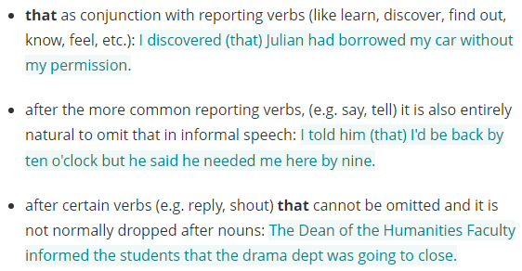
You rent an apartment and recently a new neighbor has moved in who lives above you.
They are making a lot of noise and this is disturbing you.
Write a letter to your landlord.
In your letter:
Explain what the problem is
Explain why it is disturbing you so much
Tell your landlord what you would like him/her to do about it

Dear Mr. Smith,

I am writing this letter to inform you about an issue which has totally disrupted my life here recently.

What has happened is that someone just moved in last week upstairs, and it seems like he is not aware of the volume of the noise he is making on a daily basis. He always loves singing songs very late into the mid-night and holding those parties until the sun rises.

It is especially annoying in many aspects. I rented this apartment since it is close to my college, and I can spend more time studying instead of commuting. However, there is no time for me to study anymore as the sound they make every night is unbearable. In addition, I start to feel drowsy while in classes because the time and quality of my sleep drop significantly.

I want you to take the following actions to stop the noise completely. You have to make it clear to them what are the negative influences they have caused and what are the rules they should follow to eliminate these impacts. If their behavior cannot meet the requirements, they should be kicked out of the apartment.

I look forward to seeing your response on the noise very soon.

Yours sincerely,

Bo Zhu

Take action 而不是 take actions 因为action是不可数名词
可以用 take action 或者 take the following actions
Meet the requirements 特定的 要求
In classes 而不是 on classes

A friend you met last year has invited you to visit him/her in his/her country.
You have never been there before and need some information before you leave.
Write a letter to your friend.
In your letter:
request advise about a gift for his/her family
ask about activities and clothing in his/her country
find out about the food

Dear Mandy,

Thank you for your invitation! I am writing to tell you that I can’t wait to see you and visit your city this summer.

What would you like me to bring with me as a gift to you and your family? I don’t want to miss the opportunity to surprise them with traditional Chinese products as the chance is so precious. I currently have roast ducks, snacks made of bamboo, and tea on my list. Help me pick the ones they would enjoy!

I’d like to know what activities we can do there. I remember that last time you mentioned to me that the roller coaster in your city is among the top in the world so I can’t wait to try it. Is there any local clothing that is suitable for me to wear? I don’t want to dress like I am the one who doesn’t fit in with everyone else!

As a foodie myself, I am very interested in the local food at your place. I am personally more into sweet and salty dishes but also avoid spicy food on any occasion. I heard that Americans use a variety of spices to cook chicken wings so I definitely would like to try some of them.

I look forward to hearing from you very soon. Let me know what else I have missed.

Best wishes,

Bo

无法融入他人应该是 doesn’t fit in with others

You have just read an article in an international travel magazine which contained some information about your town that is incorrect.
Write a letter to the editor of magazine.
in your letter
Correct the information in the article
Explain why it is important for the magazine to give correct information
Suggest what the magazine should do about this situation

Dear Sir or Madam,

I am one of the loyal readers of your travel magazine. I am writing this letter to inform you about some of the misinformation in it and suggest several solutions.

The misinformation was in an article, Travel to Nanjing, published in your latest magazine last month. In the article, it says that roast duck originates from Nanjing, but it is in fact one of Beijing’s traditional products. It also recommended a tourist attraction, Niu Shou Mountain, to visit that does not even exist.

It is quite necessary for you to provide accurate information in your magazines. I acknowledged that your magazines have a huge reader base, and most of them rely heavily on the information to make travel decisions. Misinformation can lead to losses in finance for your readers and, in turn, negatively affect the reputation of your brand.

Immediate measures should be taken to deal with this situation. A note for the corrections of the mistakes should be put in a conspicuous position on your company’s website, and an email should be sent to those who have subscriptions. It is also great to have the same article with the errors corrected published in the new magazines next month.

I look forward to seeing your responses on your company’s website and in your new magazines.

Yours faithfully,

Bo Zhu

Ducks originated from Nanjing 而不是 is originated from 因为 originate 是动词
Travel decisions 而不是 traveling decisions 旅游决定
Loss 前需要一个定冠词 the loss 或者 a loss in finance 因为 loss 是可数名词
Put in a position 而不是 put at a position
应该用 the same 而不是 a same 因为same 是确定性的

Write a letter to your colleague asking for help in setting up an equipment for your presentation. In your letter, you should:
tell when and where the presentation will deliver
describe your arrangements
say him/her what equipment you need.

Dear Mr. Smith,

I am writing this letter to ask for some help to set up some equipment for the company presentation that I am organizing.

This presentation is going to be held on the next Friday in the City Hall. We have booked an advanced conference room on the second floor with a computer and a projector included. It will start at 1 pm and take the time of the whole afternoon. Any guest who wants to join should arrive no later than 12.30 pm.

There will be around 200 people attending the presentation and 10 of our colleagues giving presentations about their recent achievements in the company. The whole event will take around 4 hours, and there will also be a 30-minute break for people to converse and have some refreshments.

The equipment I really need right now is several speakers. I know that you are an expert in this respect and often build speakers yourself, and that is why I resort to you. Since the conference room is pretty spacious, we would need at least four speakers to make sure everyone can hear it clearly.

I look forward to hearing from you very soon! Let me know if you need anything in return.

Bo Zhu

Equipment 是不可数名词 a piece of equipment 或者 equipment
Any guest who wants to joins 主语 谓语 单复数一致

You have seen a job advertised in the newspaper. You want to apply for the job.
Write a letter to the manager of the company.
In your letter
• provide information about yourself
• give details of your previous work experience
• Say why the company should consider you for the job

Dear Sir or Madam,

I just saw the hiring information of your company posted on CNBC newspaper. I am writing this letter to apply for the Senior Java Developer position.

I am a Java developer with three years of working experience. I graduated from Nanjing university in 2019 with a Master’s degree in Software Engineering, and I am looking for new employment opportunities. I am a 26-year-old single male and can accept working overtime if the compensation is appropriate.

I have been working for State Grid Corporation of China since my graduation, and I am still working there at the moment. In this company, I have participated in two very important projects, the renewable energy platform and the unmanned aerial vehicle management system, both of which required me to combine and apply my knowledge in Java, C#, and Python proficiently .

I think I am a great fit for this position since you mentioned that candidates need to be familiar with major artificial intelligence and big data frameworks. I was particularly in charge of the AI part of my previous projects and understand the merits and drawbacks of the most popular AI frameworks in depth. It allows me to develop an AI system from scratch to maturity at a fast speed.

I look forward to hearing from you soon, and I cannot wait to have an interview in person.

Yours faithfully,

Bo Zhu

Drawback 和 merit 都是可数名词，应该用 drawbacks
Three years of working experience 或 three years’ working experience
而不是 three years working experience
The renewable energy platform and the unmanned aerial vehicle management system
这两个单词 前面要不然加 a 单数 要不加 the 做定冠词

